**MEDICAL DATASET FOR COMPARISON BETWEEN HEALTHY AND IDEOPATHIC TOE WALKING TO IDENTIFY IF A PERSON IS HEALTHY OR SUFFERRING FROM ITW.**

**IMPORTING THE ZIP FILES HEALTHY.ZIP AND ITW.ZIP**

from google.colab import files

uploaded = files.upload()

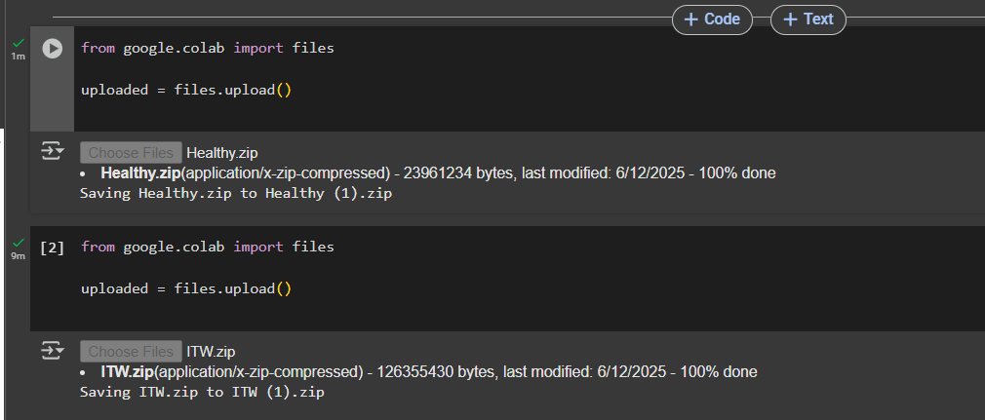

**STEP 2: Unzip the file to a known directory**

import zipfile

import os

zip_path = "/content/Healthy.zip"

extract_dir = "/content/extracted_c3d/Healthy"

os.makedirs(extract_dir, exist_ok=True)

with zipfile.ZipFile(zip_path, 'r') as zip_ref:

    zip_ref.extractall(extract_dir)

**STEP3-UNZIP THE EXTRACTED C3D FILE**

import zipfile

import os

with zipfile.ZipFile("ITW.zip", 'r') as zip_ref:

    zip_ref.extractall("extracted_c3d/ITW")

print("Unzipped files to extracted_c3d/ITW")

**STEP 4: Define skeleton plotting and image conversion logic Because .c3d format is not identifiable by pytorch**

!pip install ezc3d

import ezc3d

import matplotlib.pyplot as plt

from tqdm import tqdm

def plot_skeleton(c3d, frame_idx, save_path):

    fig = plt.figure()

    ax = fig.add_subplot(111, projection='3d')

    points = c3d['data']['points']

    x, y, z = points[0, :, frame_idx], points[1, :, frame_idx], points[2, :, frame_idx]

    ax.scatter(x, y, z, c='blue')

    ax.set_axis_off()

    plt.savefig(save_path)

    plt.close(fig)

def convert_healthy_c3d_to_images(healthy_input_path, output_root="/content/healthy_skeleton_images", max_frames=30):

    os.makedirs(output_root, exist_ok=True)

    files = [f for f in os.listdir(healthy_input_path) if f.endswith('.c3d')]

    print(f"Found {len(files)} .c3d files.")

    for filename in files:

        file_path = os.path.join(healthy_input_path, filename)

        subject_id = os.path.splitext(filename)[0]

        subject_out_dir = os.path.join(output_root, subject_id)

        os.makedirs(subject_out_dir, exist_ok=True)

        c3d = ezc3d.c3d(file_path)

        num_frames = min(c3d['data']['points'].shape[2], max_frames * 5)

        for i in tqdm(range(0, num_frames, 5), desc=f"Healthy - {filename}"):

            save_path = os.path.join(subject_out_dir, f"frame_{i:04d}.png")

            plot_skeleton(c3d, i, save_path)

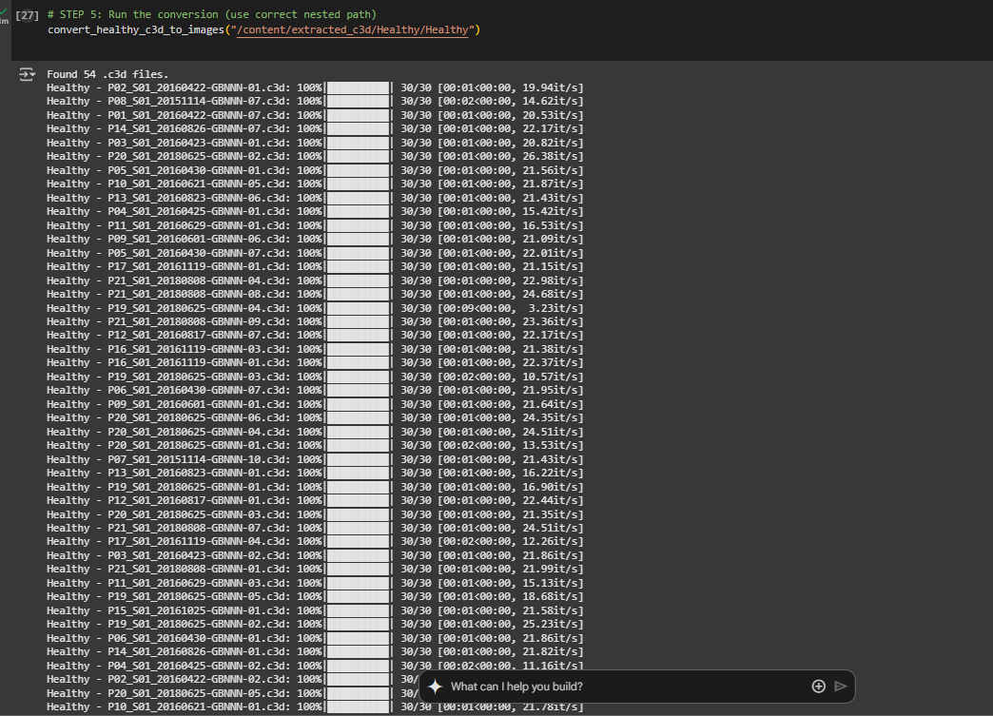

import ezc3d

import matplotlib.pyplot as plt

from tqdm import tqdm

def plot_skeleton(c3d, frame_idx, save_path):

    fig = plt.figure()

    ax = fig.add_subplot(111, projection='3d')

    points = c3d['data']['points']

    x, y, z = points[0, :, frame_idx], points[1, :, frame_idx], points[2, :, frame_idx]

    ax.scatter(x, y, z, c='blue')

    ax.set_axis_off()

    plt.savefig(save_path)

    plt.close(fig)

def convert_next_100_c3d_to_images(input_dir, output_dir, start=0, max_frames=30):

    import glob

    import os

    all_c3d_files = sorted(glob.glob(os.path.join(input_dir, '**', '*.c3d'), recursive=True))

    batch_files = all_c3d_files[start:start + 100]

    if not batch_files:

        print("No .c3d files found in this batch.")

        return

    os.makedirs(output_dir, exist_ok=True)

    for file_path in tqdm(batch_files, desc=f"Processing {len(batch_files)} files from index {start}"):

        subject_id = os.path.splitext(os.path.basename(file_path))[0]

        subject_out_dir = os.path.join(output_dir, subject_id)

        os.makedirs(subject_out_dir, exist_ok=True)

        try:

            c3d = ezc3d.c3d(file_path)

            num_frames = min(c3d['data']['points'].shape[2], max_frames * 5)

            for i in range(0, num_frames, 5):

                save_path = os.path.join(subject_out_dir, f"frame_{i:04d}.png")

                plot_skeleton(c3d, i, save_path)

        except Exception as e:

            print(f"Error processing {file_path}: {e}")

put_itw = "extracted_c3d/ITW"

output_itw = "batched_skeletons/ITW"

convert_next_100_c3d_to_images(input_itw, output_itw, start=0)

convert_next_100_c3d_to_images(input_itw, output_itw, start=100)

similarly for remaining 300 images

**STEP 6-COUNT THE NUMBER OF IMAGES IN HEALTHY AND ITW FOLDERS TOCHECK IF ALL THE IMAGES HAVE BEEN CONVERTEDED IN SKELETON FORMAT(.png)**

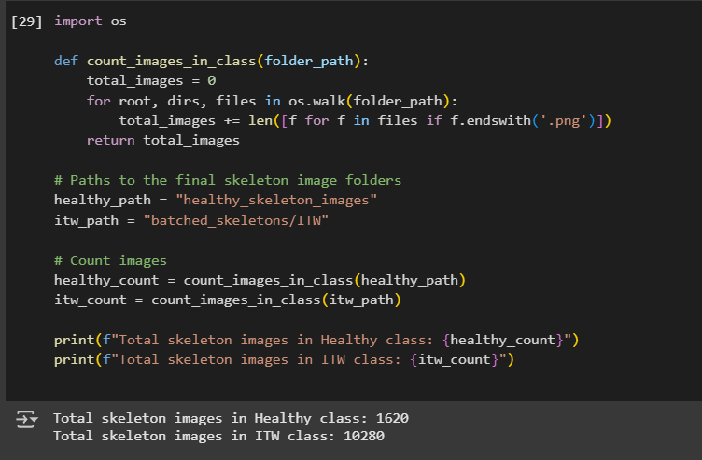

**STEP 7-COMBINING HEALTHY AND ITW DATASETS PROCESSED INTO A NEW FOLDER CLASSIFIED_DATASET**

import os

import shutil

healthy_src = "/content/healthy_skeleton_images"

itw_src = "/content/batched_skeletons/ITW"

base_dest = "/content/classified_dataset"

healthy_dest = os.path.join(base_dest, "Healthy")

itw_dest = os.path.join(base_dest, "ITW")

os.makedirs(healthy_dest, exist_ok=True)

os.makedirs(itw_dest, exist_ok=True)

for folder in os.listdir(healthy_src):

    folder_path = os.path.join(healthy_src, folder)

    if os.path.isdir(folder_path):

        for file in os.listdir(folder_path):

            if file.endswith(".png"):

                src_path = os.path.join(folder_path, file)

                dst_path = os.path.join(healthy_dest, f"{folder}_{file}")

                shutil.copy(src_path, dst_path)

for folder in os.listdir(itw_src):

    folder_path = os.path.join(itw_src, folder)

    if os.path.isdir(folder_path):

        for file in os.listdir(folder_path):

            if file.endswith(".png"):

                src_path = os.path.join(folder_path, file)

                dst_path = os.path.join(itw_dest, f"{folder}_{file}")

                shutil.copy(src_path, dst_path)

print(" Dataset organized at:", base_dest)

SPLITTING THE DATA INTO TRAIN AND TEST DATA

from torchvision import datasets, transforms

from torch.utils.data import DataLoader

transform = transforms.Compose([

    transforms.Resize((224, 224)),

    transforms.ToTensor()

])

dataset_root = "/content/classified_dataset"  # folder with 'Healthy' and 'ITW'

train_dataset = datasets.ImageFolder(root=dataset_root, transform=transform)

train_loader = DataLoader(train_dataset, batch_size=32, shuffle=True)

**STEP 9-IMPORT LIBRARIES AND SET UP TRANSFORMS**

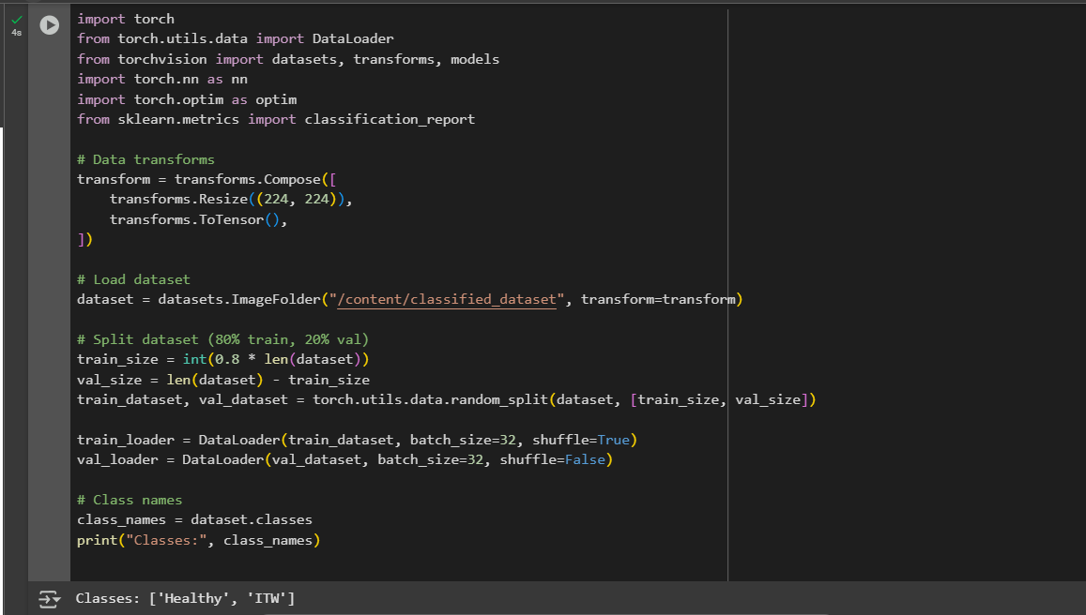

**STEP 10-LOAD PRETRAINED MODEL(ResNET 18)**

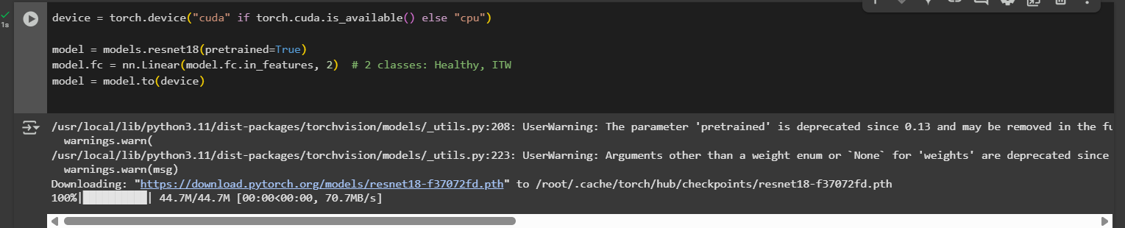

**STEP 11-DEFINE LOSS AND OPTIMIZER**

criterion = nn.CrossEntropyLoss()

optimizer = optim.Adam(model.parameters(), lr=1e-4)

TRAIN THE MODEL

num_epochs = 5

for epoch in range(num_epochs):

model.train()

total_loss = 0

correct = 0

for images, labels in train_loader:

images, labels = images.to(device), labels.to(device)

optimizer.zero_grad()

outputs = model(images)

loss = criterion(outputs, labels)

loss.backward()

optimizer.step()

total_loss += loss.item()

correct += (outputs.argmax(1) == labels).sum().item()

acc = correct / len(train_loader.dataset)

print(f"Epoch {epoch+1}, Loss: {total_loss:.4f}, Train Accuracy: {acc:.4f}")

EVALUATE THE MODEL

model.eval()

all_preds = []

all_labels = []

with torch.no_grad():

for images, labels in val_loader:

images = images.to(device)

outputs = model(images)

preds = outputs.argmax(1).cpu().numpy()

all_preds.extend(preds)

all_labels.extend(labels.numpy())

print(classification_report(all_labels, all_preds, target_names=class_names))

**STEP 12-TRAINING THE MODEL**

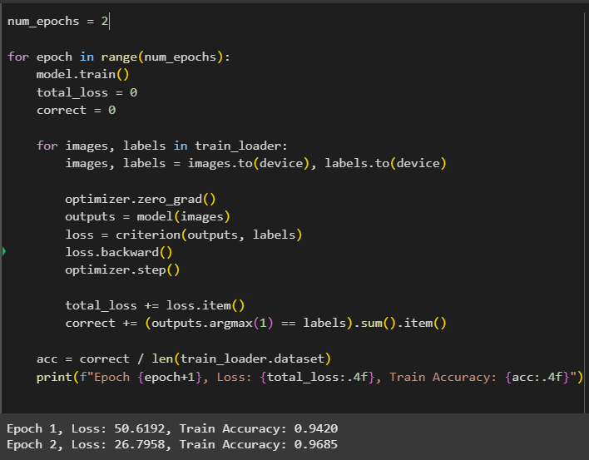

Trains the model using cross-entropy loss.

Updates model weights using Adam optimizer.

**STEP 13-EVALUATION OF THE MODEL**

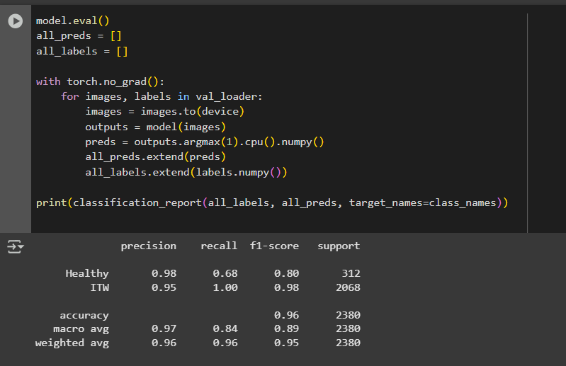

Precision for Healthy: **0.98**, but recall is low (0.68), meaning some Healthy samples were misclassified.

Precision for ITW: **0.95**, recall is perfect (1.00).

Overall accuracy: **96%**